VPC Challenge

Use Case: Setting up Transit Gateway and VPC Endpoints for a Multi-VPC Architecture
Scenario:
A large organization is migrating its on-premises infrastructure to the AWS cloud.
The organization's architecture involves multiple VPCs for different departments and applications, each requiring secure communication with centralized services and external resources.
The IT team needs to design and implement a scalable and efficient network architecture to accommodate the organization's growth and ensure robust connectivity between VPCs and external services.
Objectives:
- Design and deploy a scalable network architecture using AWS Transit Gateway to simplify network connectivity between multiple VPCs.
- Configure VPC endpoints to securely access AWS services without internet gateways or NAT gateways, ensuring data privacy and minimizing exposure to external threats.

  - Step 1: Design and deploy a scalable network architecture using AWS Transit Gateway to simplify network connectivity between multiple VPCs.
    - The first step is to create multiple VPC’s and route all the networks via Transit Gateway.

- Set-up a Transit Gateway
- Created 4 new VPC’s and provided ranges below.
  - 172.31.0.0/16
  - 10.0.0.0/228
  - 10.0.1.0/28
  - 10.0.2.0/28
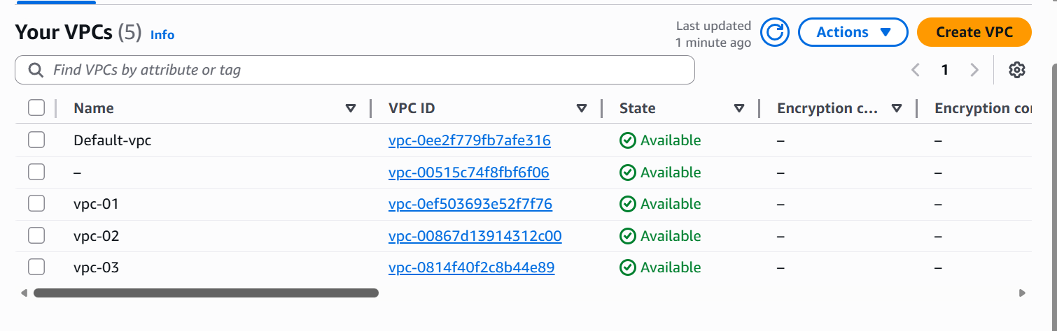
- Created 4 subnets with a ranges below.
  - 172.31.0.0/16- default
  - 10.0.0.0/28
  - 10.0.1.0/28
  - 10.0.2.0/28
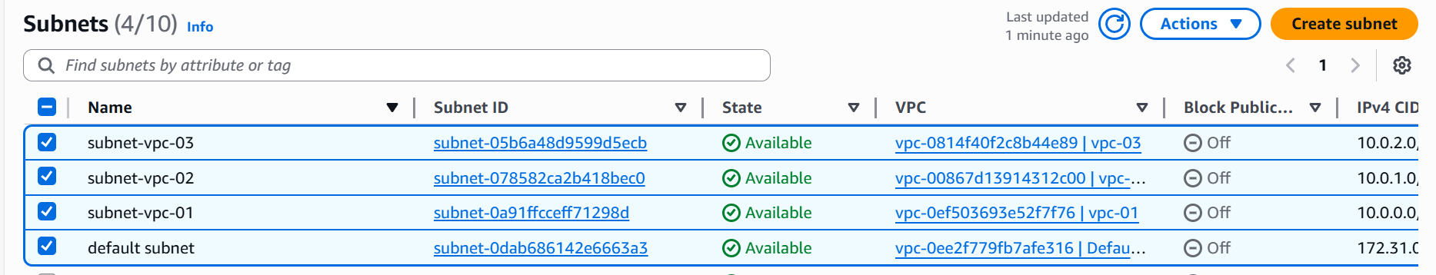
- Created Transit gateway and will attach all VPC’s to the gateway created.
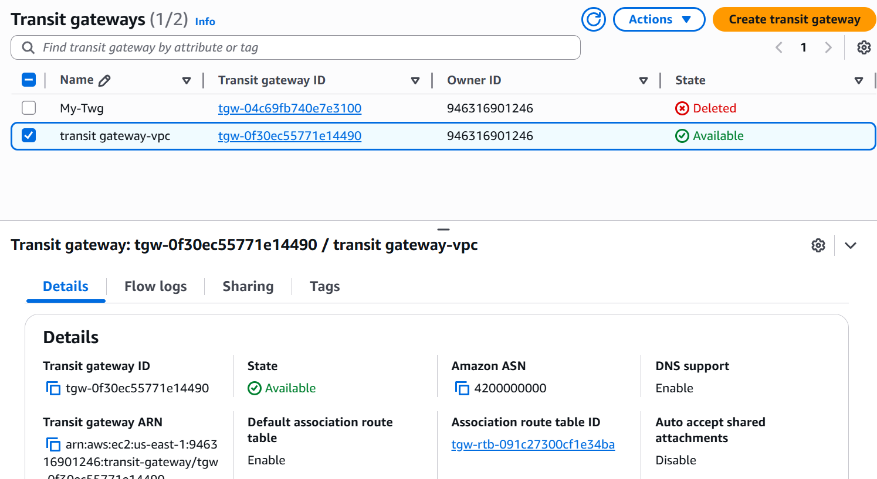

- Created 3 Transit Gateways attachments and attached all VPC’s to it.
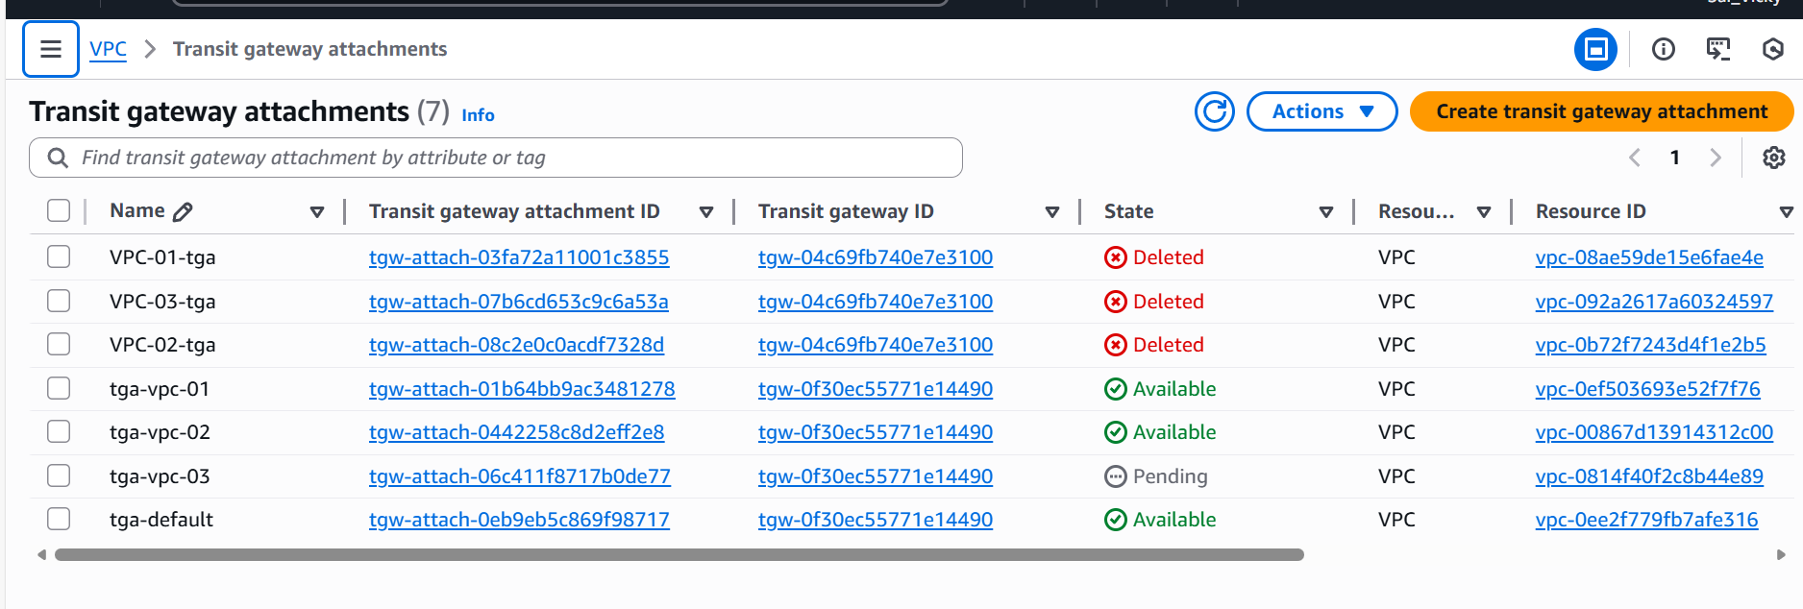
- In the below, Transit gateway route tables, we have to attach all VPC ranges.
- Transit gateway attached to all VPC’s.
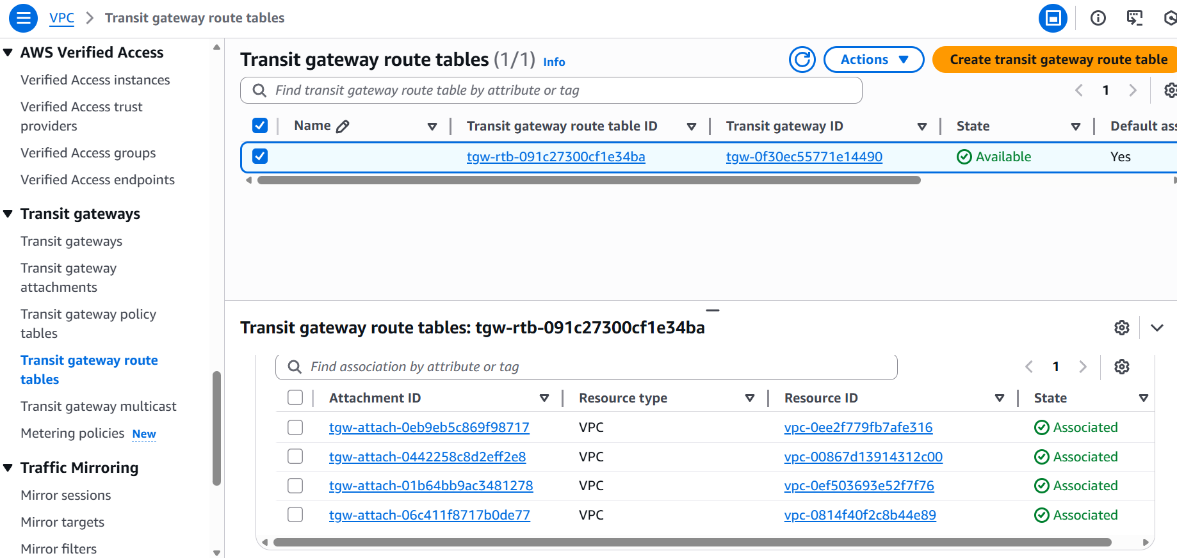

- Launched all 4 instances using all 4 VPC’s created and 4 subnets attached from VPC’s created as well.
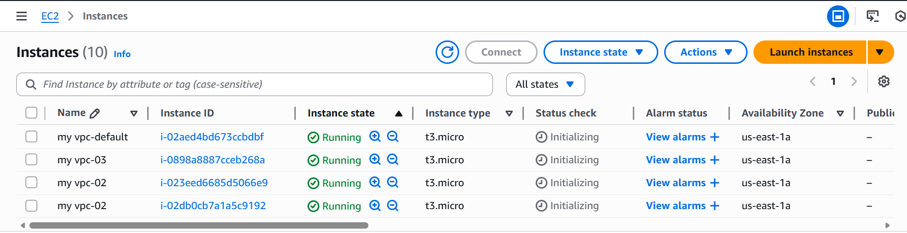

- Now, we need to attach all VPC ranges to the routing tables for all 4 VPC’s with transit gateway.
- In the below route table, we attached the VPC-01, VPC-02 and VCP-03 CIDR ranges and added under Transit Gateway.

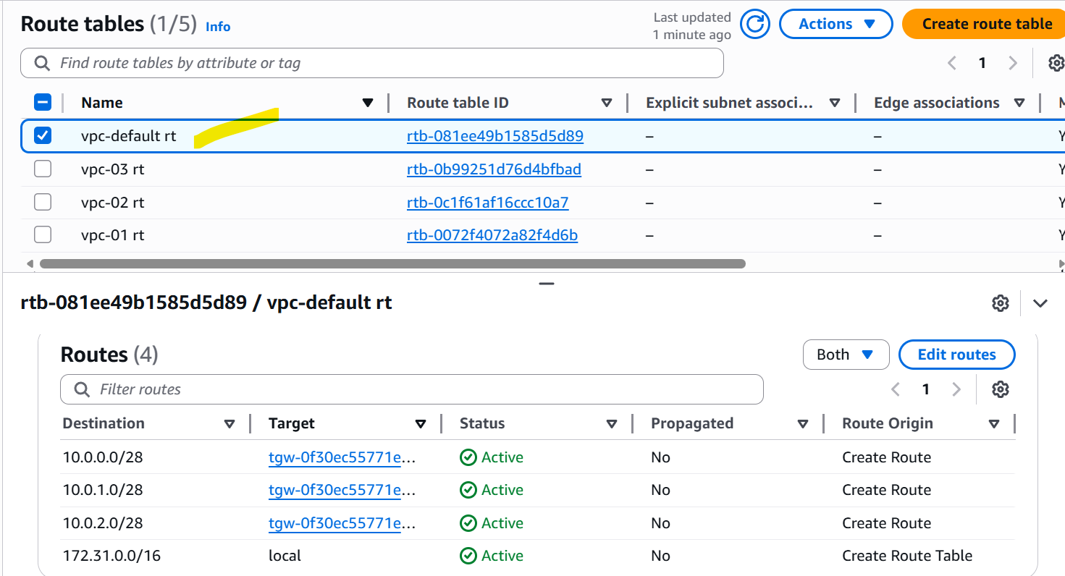
- In the below route table, we attached the VPC-default, VPC-02 and VCP-03 CIDR ranges and added under Transit Gateway.
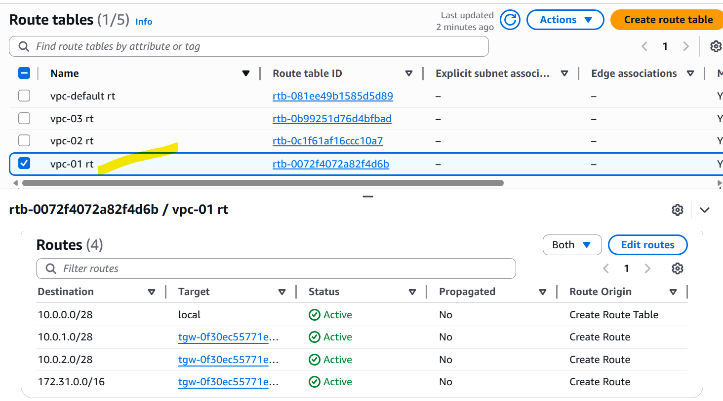
- In the below route table, we attached the VPC-default, VPC-01 and VCP-03 CIDR ranges and added under Transit Gateway.
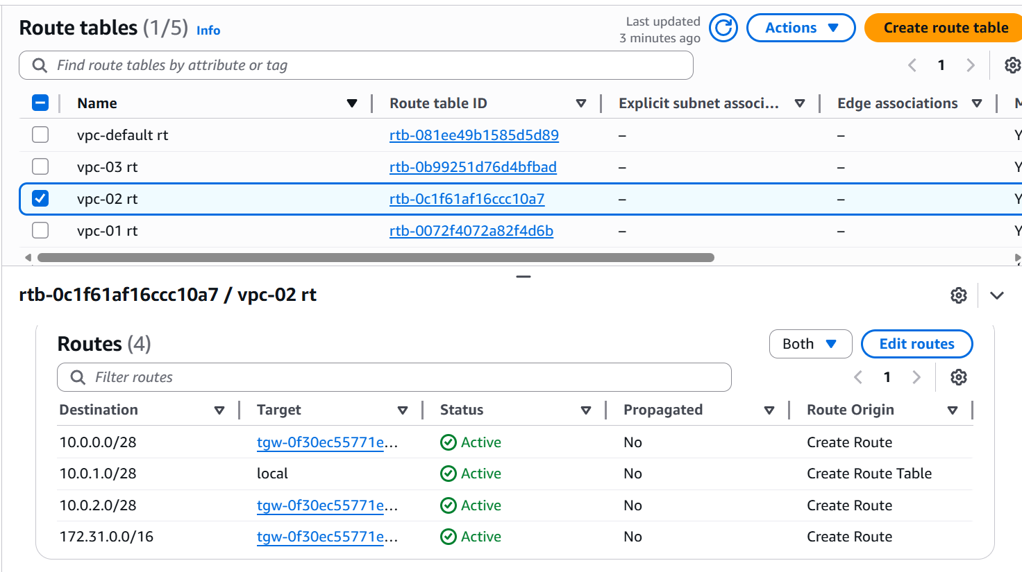
- In the below route table, we attached the VPC-default, VPC-01 and VCP-02 CIDR ranges and added under Transit Gateway.
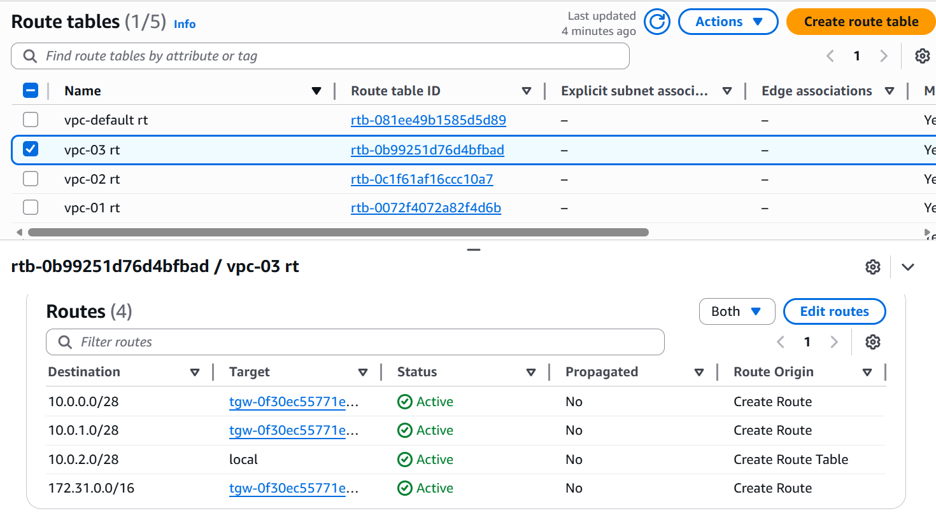

Now, we need to add Internet gateways and attach all 4 VPC’s.
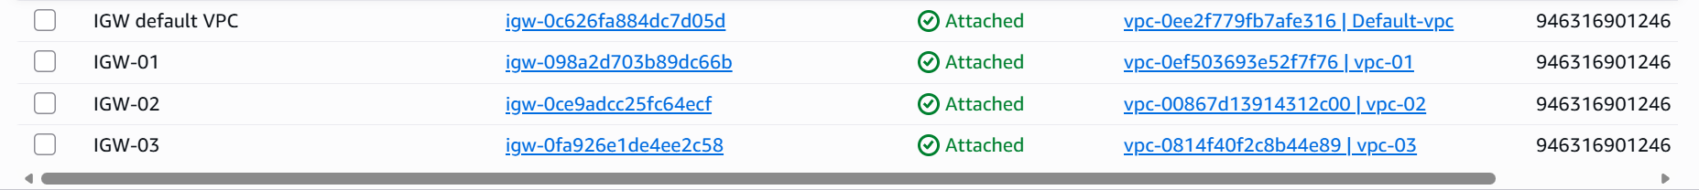
- Now, we need to attach Internet gateway to the route tables by allowing all traffic.
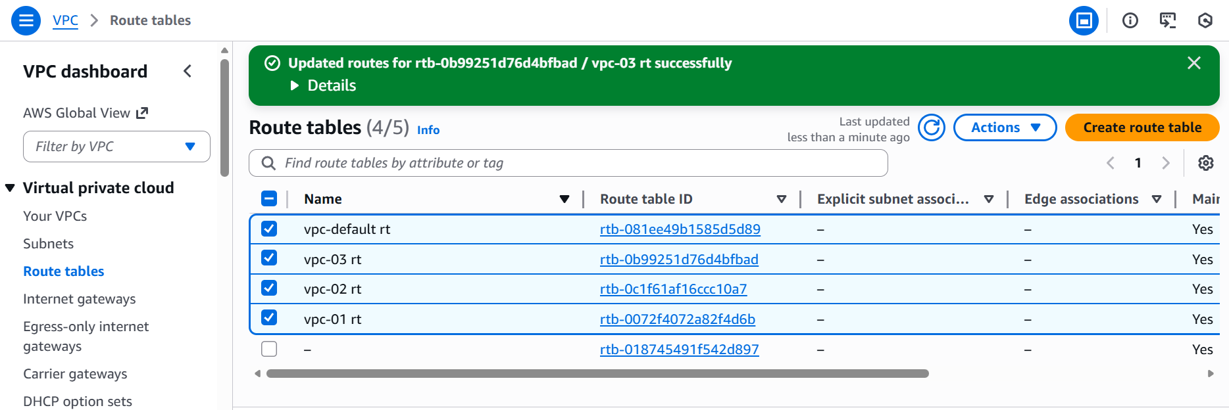
- The final step in ec2 is to add “All Traffic” for all 3 instances and save.
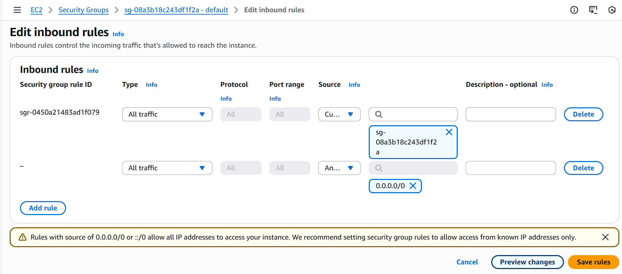

- Pinged from default VPC to VPC-01
- Success
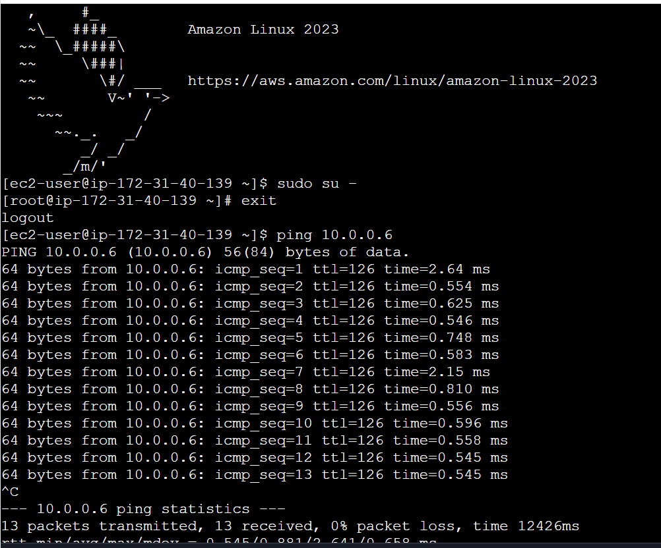
- Pinged from VPC-03 to VPC-01
- Success
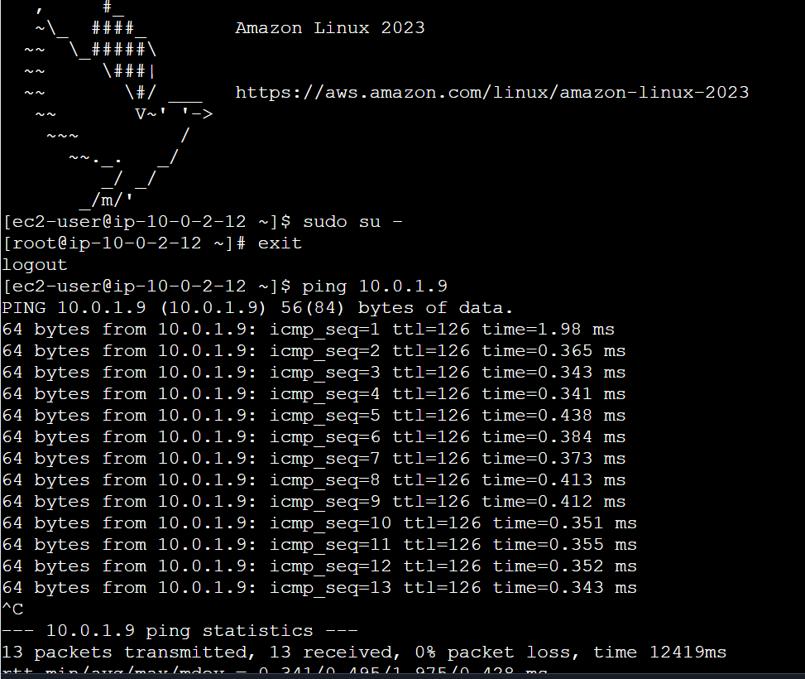

- Next question is to peer the Default VPC to another account- Account holder B.
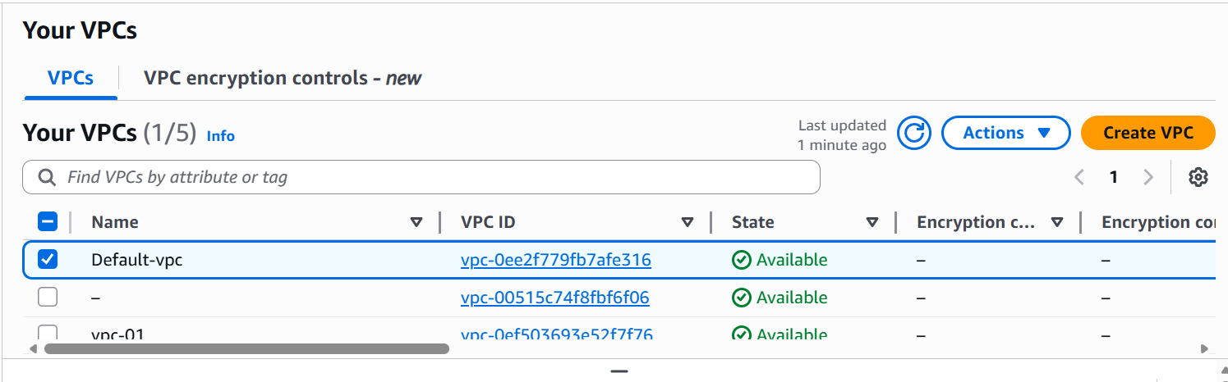
- VPC peering request has been sent to Account holder-B
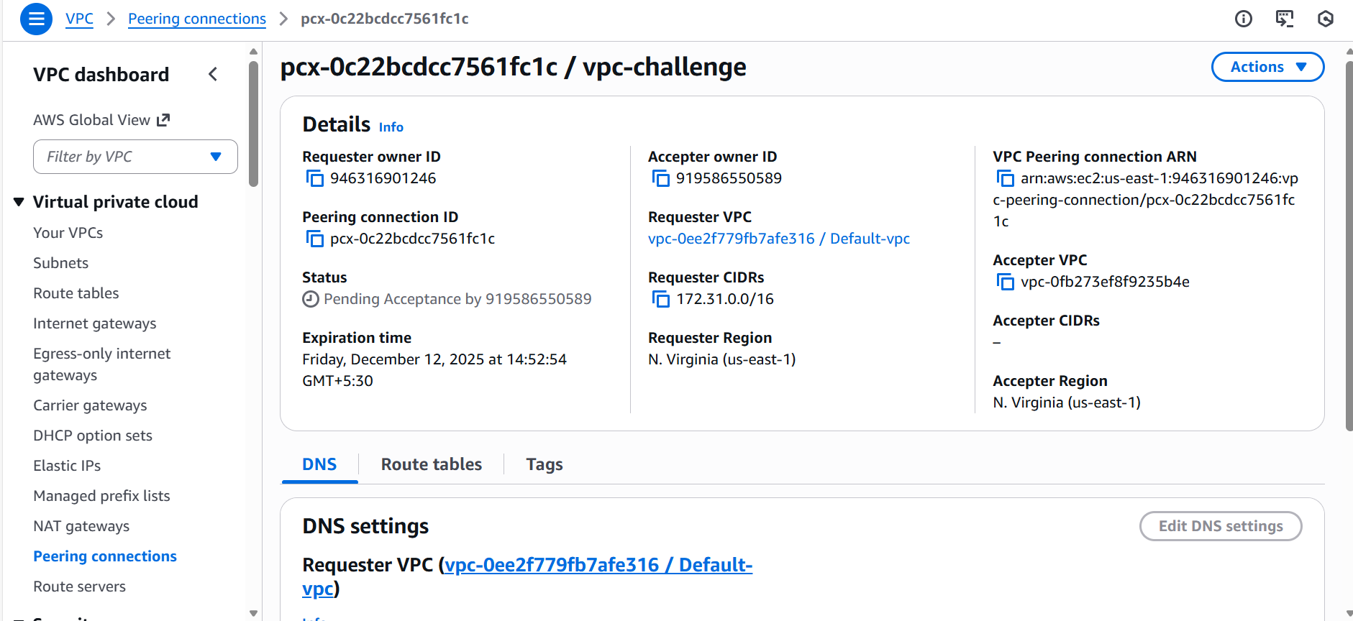
- VPC peering is waiting to be accepted at Account holder-B.

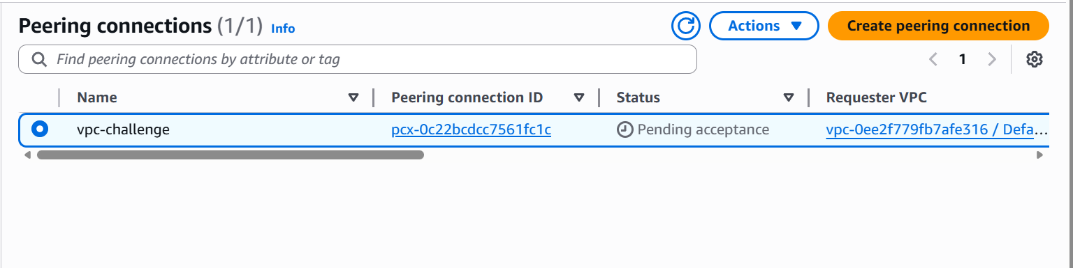

- Peering connection successful.
- Task completed.
